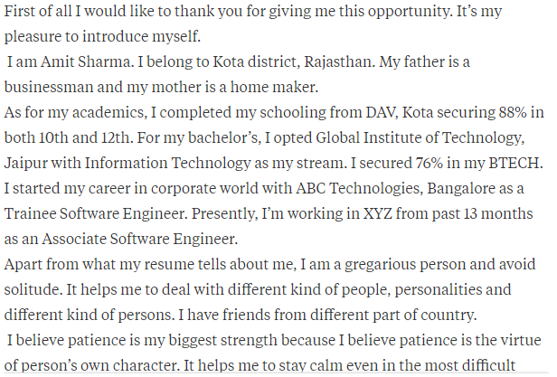

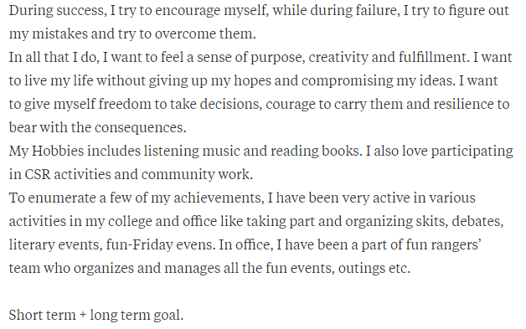

**Short term and long term goal**

My goal is to work for the company like Infosys where I can enhance my technical skills and knowledge, and my long-term goal is to see myself at a topmost position in a reputed company like yours.

**Why should I hire you?**

 I believe that everyone start **from** beginning, I need a platform where to prove my skill and abilities, I think your company is a right place to explore my abilities. I need to be a part of your company growth. I will give my best.

**Introduce yourself and say something apart from your Resume.**

**Apart from ,what my resume tells about me. I born and raised in Akola city. After completing my BE, I came to Pune for doing job and learning technical things. Here, in my early phase I started facing few difficulties but after some days, I was able to sort out almost every problem.** I believe that patience is my biggest strength because it helps me to stay calm in most difficult situation, during success I encourage myself but during failure I figure out my mistakes and try to overcome them. Coming to **my weakness I am emotional kind of person, but this might be helpful in maintaining the proper relationship.**

### Why have you applied at Infosys?

Infosys is the second-largest revenue earning IT Company in India. Every person wants to work for your company and need to be part of your Company growth.

### You had to wait for 8 (Syntel) hours for the interview. Are you feeling tired?

“No. This is my dream company so wait doesn't matter. I have enough time for the interview."

### Who is your role model? What have you incorporated into your life from him/her?

**Example:** The role model of my life is my father, Whenever I am down my father helps me to push my limits, and he always keeps me on the track. He scolds me every time when I do something wrong, and I always got inspired from him how he manages every problem in every situation. He is everything for me.

### What Four things would make a good leader?

The three things would make a good leader are listed below:

* **Earn** the Respect of the Team
* **Make** the Hard Choice
* Being **close** to your team members.

### What is the success?

Success refers to the **accomplishment** of an aim or purpose.

### What was the hardest experience you ever experienced?

The hardest experience I had experienced in my life is doing my university project alone because no one understands my project idea.

### Tell me one real-time situation where you have emerged as a Leader?

I don't have any work experience, so I have no such real-time situation when I have emerged as a leader but, in my college, I **have been the leader** of the group project. In my team, I have emerged as a leader.

### Where will you like to see yourself in the next five years?

I will see myself in a reputed and top most position in my company.

**What is your ultimate goal in life?**

My goal is to work for the company like Infosys where I can enhance my technical skills and knowledge, and my long-term goal is to see myself at a topmost position in a reputed company like yours.

**Which personal attributes do you have?**

* I always **stay** positive.
* I **hold** a positive attitude towards all my elders and Youngers.

### Where do you rate yourself as an engineer?

I will rate myself 7 out of 10 as an engineer because there are always **some things** which have to learn in life.

### What is your strong point regarding technical knowledge? Like JAVA, C, C++.

My strongest point of technical knowledge is programming. I like every programming language because programming **is as easy as telling someone to perform some task, for that you need the some communication language. The only difference is we are telling task to the computer instead of the humans.**

### Why are you applying for this job? (or)

### Why this role attract you?

### Would you like to work overtime or odd hours?

You should become very honest to answer this question. Don't tell a lie or compromise to get the job only. If you don't have any problem, you can answer like this:

 I know that in the company being asked to work for an extended number of hours comes with a good reason,so I am ok with it.

**It an extra effort means I am doing something for the company, I'll be happy to do it**

### What is more important to you: the money or the work?

### I believe that work is important. Bz If we work and achieve company goals then obviously money would follow us. I will give priority to work first.

### Would you lie for the company?

You should answer this question in a very diplomatic manner.

"It depends on the situation if my lie creates a positive impact on the company and It will useful for many people, then I will lie."

### Are you applying for other jobs also?

You should never claim that you did not apply to other company. Despite this, you can say that –

As you know, I would like to work as a software developer. **Beyond your company,** I have also applied to XYZ company and ABC company. This answer is more specific

### Describe yourself in one word?

If he uses a word, he must be able to explain that word and also represent himself according to that word.

Original, genuine, **logical**, **incredible**, **focused**, **curious**, **active**, **quick**, balanced, **achiever**, etc.

### What is the difference between confidence and overconfidence?

Confidence is an **internal belief** that I am a right person for this job and overconfidence is **thought** that I am only the right person for this job.

There is a small difference between confidence and overconfidence. Yes, I can do this work is self-confidence. But **only** I can do this work is overconfidence.

### What is the difference between smart work and hard work?

Without being a hard worker, we can't be a smart worker. Smart work comes from the hard work.

**So hard work increases your accuracy, and smart work increases accuracy as well as efficiency**.

### Just imagine that you have enough money to retire right now. Would you?

"No sir, I don't think so. I am a professional, and I love my work, so there is no question to leave my work. Yes, it may be that I would take a break to spend quality time with my family.